Creating UTM URLs to Track Your Campaigns
Last Updated / Reviewed: Feb 3rd, 2021
Execution Time: ~1-2 minutes


Goal: To easily create and keep a database of all the UTM URLs for the different campaigns you use to drive traffic to your site.

Ideal Outcome: You have a consistent usage of UTM parameters across your team, platforms, and campaigns that allows you to easily understand the impact of your different campaigns using tools like Google Analytics.

Why this is important: UTM URLs allow you to assess how effective your marketing activities are, but it is often difficult to establish a consistent usage of UTM URLs.

Where this is done: In your UTM Campaign Builder spreadsheet (provided).

When this is done: Any time you plan on linking to your site as a part of a specific campaign (paid or not.)

Who does this: The person responsible for executing the campaign.

Environment Setup

- Open and make a copy of the UTM Campaign Builder spreadsheet.
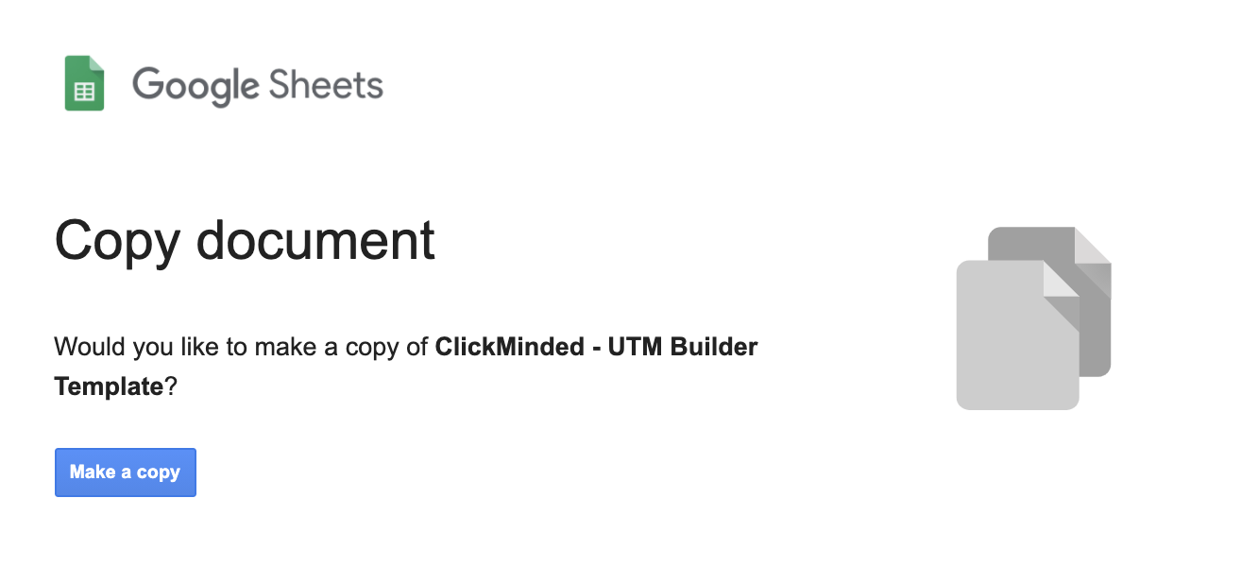
Important: You only need to do this once. After that, you should continue using the same spreadsheet for all of your campaigns.

Using the UTM Campaign Builder

The spreadsheet makes it easy for you to create and keep track of all the UTM campaigns you and/or your team creates.

- First, you need to understand best practices to enter your campaign information in the sheet:
  - Fill out the campaign information (source, medium, name, term, and content).
  - Avoid using special characters. Stick to letters and numbers.
  - This spreadsheet will give you an URL that will:
    - Always use lowercases.
      - Why: Google Analytics UTM tags are case-sensitive. You do not want to miss data by being unsure whether or not you’ve cased a certain campaign.
    - Never use spaces, instead, will always replace them by dashes.
      - Why: Spaces aren’t allowed in URLs, instead they are encoded into %20 character groups. You should also have a rule in your organization to normalize how spaces should be handled and keeping it consistent, this spreadsheet does it for you.
    - Automatically log the current date when the URL was generated.
      - Why: You want to keep a time-reference on your tags both inside Google Analytics and on your UTM log. When analyzing big enough time-periods you will want to quickly have a general idea of the period when that specific URL was promoted. The date is also generated in a way that allows you sort them by date inside Google Analytics by sorting it by “name” inside the platform:
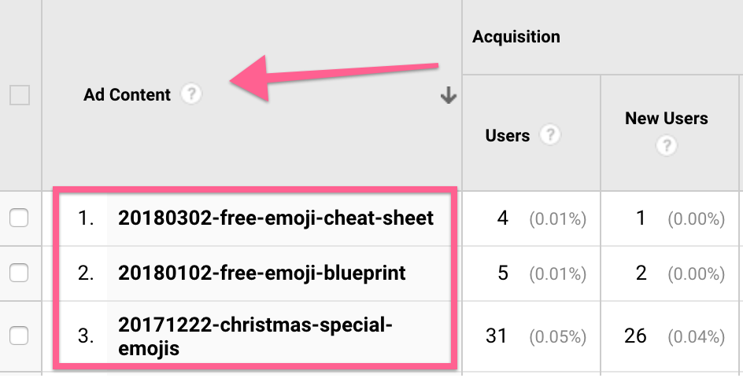
    - Select your Source, Mediums, and Placements from a configurable list.
      - Why: You want to make sure everyone in your organization tags those parameters the same way. (e.g: If one teammate uses utm_source=fb and the other uses utm_source=facebook, your data will be much harder to analyze)
- Setting up your spreadsheet and customizing it to your organization:
  - Open the UTM Campaign Builder Spreadsheet.
  - Click the “Settings: Source/Medium/Placements”
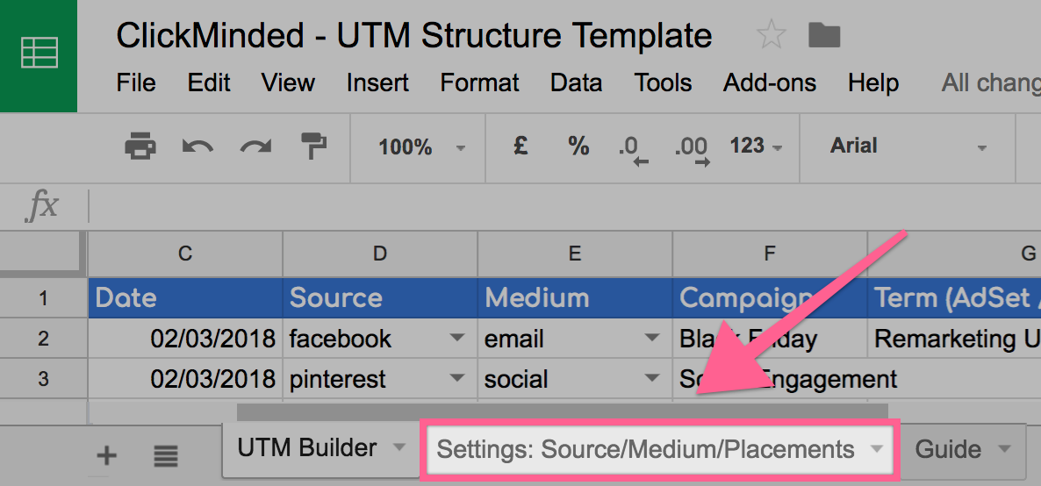
  - Edit the list with the values that you would like to see on the dropdown of the main spreadsheet. These should be the Sources, Mediums, and Placements that you currently use.
    - Note: You will note that the spreadsheet already has predefined values. You can use those values, add new ones, or delete them as you find suitable. In any case, the only value you should not delete is on line 3 the cells set as “notset”:

- All you need to do is fill out the following information:
  - Name of the person creating the URL:
  - URL for the campaign (required). This is the page in your site that you will link to:
  - Date is filled automatically for you:

  - The source of the traffic for this URL (required):
    - Example: google, facebook, quora, etc
  - The campaign medium (optional but recommended). This is the marketing channel or medium you are using to share your link.
    - Example: cpc, email, etc
  - The campaign name (optional but recommended). This is the campaign that this URL will relate to.
Example: “Black Friday”
  - The campaign term (optional). You can use this to specify the keywords or terms being targeted in the ads using this URL or to note the segmentation being used in your campaign
    - Example: “Remarketing US 20-45”.
  - Facebook Ad Placement (optional). You can use this to specify what specific placement on Facebook Ads this URL belongs to.
    - Note: Make sure you are using the correct URLs on each placement. (Example: If you generate a UTM tag containing ‘rightcolumn’ make sure you don’t use that URL on your News Feed ads as well.
  - The campaign content (optional but recommended). This is the content being shared in the campaign (for example: explainer video, seo certification, seo webinar)

- The UTM URL will be automatically generated for you. You can copy the resulting URL from column H.
- That’s it! Your URL has been generated and your traffic will be properly tracked in Google Analytics. It is recommended that you test your URL before publishing your campaigns.

Check your UTM URLs

Note: This step requires Google Chrome’s Google Tag Assistant extension to be installed on your browser.

- Open your UTM URL in your browser.
  - Example: https://www.asiteaboutemojis.com/?utm_source=newsletter&utm_medium=email&utm_campaign=black-friday&utm_term=remarketing-us-20-45&utm_content=20180307-rightcolumn-free-emoji-cheat-sheet
- Click on the Tag Assistant extension icon next to the address bar, and then hit “Record”:
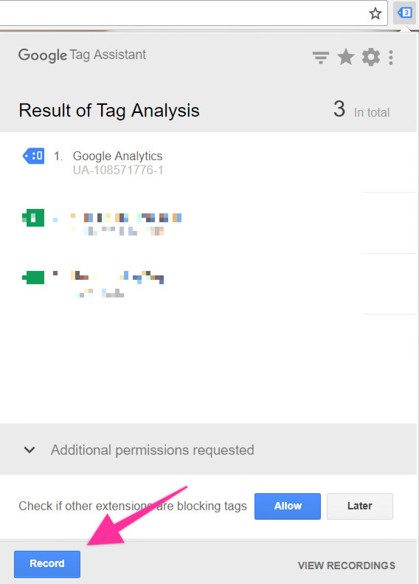
- Refresh your page.
- Click on the Tag Assistant extension icon again and then click “Stop Recording”: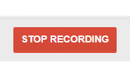
- Click “Show Full Report”:

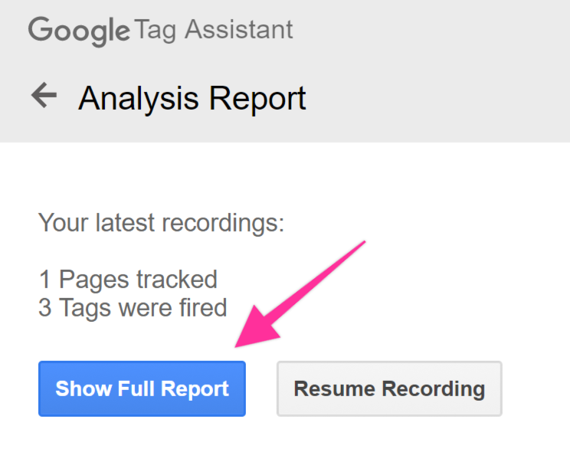
- You will be taken to the Google Tag Assistant Report. On the top, click on “Google Analytics Report”.
  - Note: You need to be logged in to a Google Account that has access to the Google Analytics account for your website.
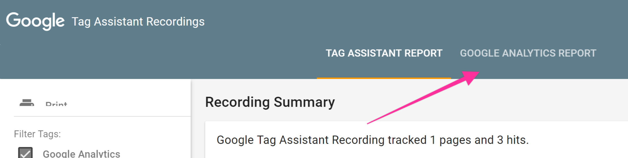
  - Note: If you see a message displaying “No hits were found in this recording.” It means your own traffic is not being recorded, most likely due to an AdBlocker, Privacy Extension, or the Google Opt-Out extension. Make sure you disable those temporarily in order to properly follow this process.
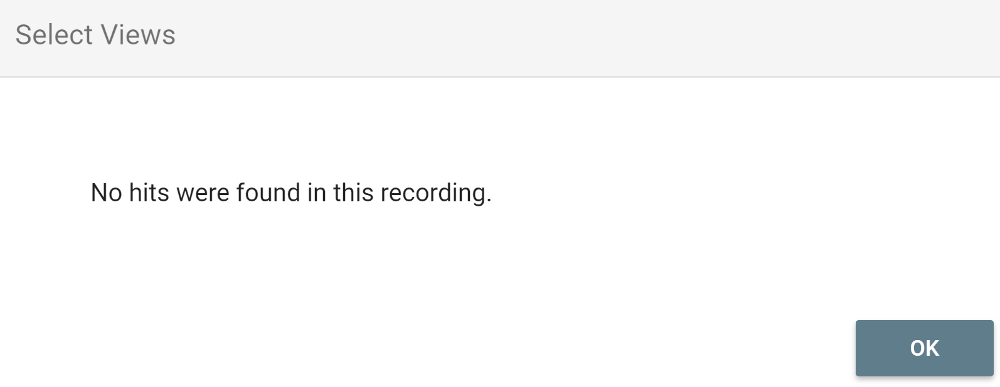
- If you have multiple views configured in Google Analytics you should select the views you want to analyze (you can select all of them) and then hit “Ok”:
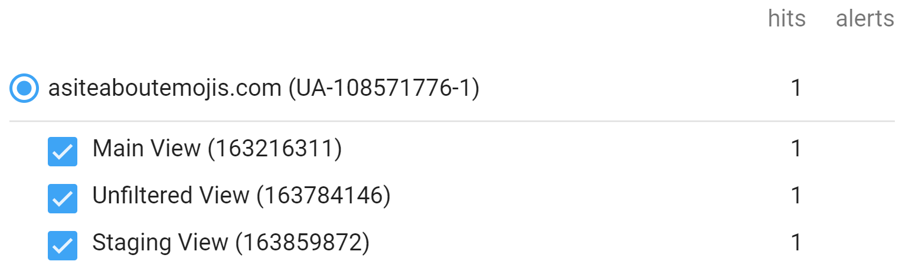

- Scroll down the report until the “Acquisition” section. You should be able to see the same inputs you had on your spreadsheet:
